Demo Script

Introduction
This document is intended to help Solution Providers present Ecrion Software for typical customer use cases to a Business Decision Maker audience. This script is based on best practices from the Ecrion Sales Team and leverages assets available on the Ecrion website and samples available in the demo environment provisioned to partners.

Overall Approach
When you do a demo, start by setting expectations.
- There are too many features to cover in a limited amount of time so focus on a few.
- Show features and functionality that fit a prospect’s use case and industry.
- Connect the dots from the creation of the content to the delivery by channel and device.
- The “Tour” metaphor works well. We are sight-seeing the system. Speak like a tour guide, not a trainer.
- Focus on the business value of the solution to support the customer’s specific challenges or pain points.

Audience
The target audience for Ecrion products varies by module and may include representatives from multiple departments. They are concerned with the production, distribution and omni-channel delivery of documents. Developers will often sign up for a trial to evaluate the product. Your goal is to secure a demo with the key decision makers who control the budget and/or represent the departments that reap the benefits.
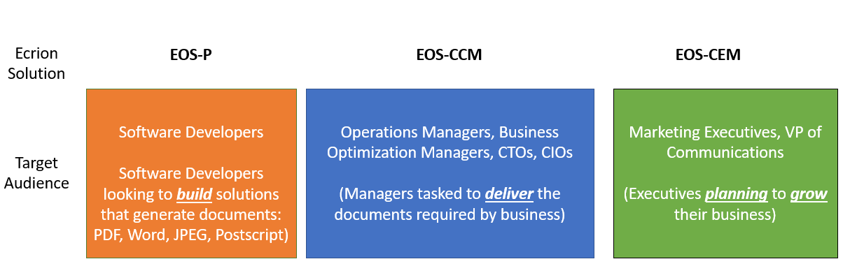

4 Use Cases and Customer Requirements

When you schedule a product demonstration it should be tied to one or more customer use cases that map to customer requirements. Frequently, the customer has already expressed an interest in seeing a very specific feature or workflow that responds to a pain point or you have identified a need that corresponds to a feature/functionality in Ecrion. Generally, it is premature to invest resources in a demo if you haven’t captured the underlying business or technical problem.

The most common uses cases for EOS CCM:
- Batch (Volume) - Automatic production of transactional documents (statements, invoices, letters, notifications) in high volumes. Operation managers usually schedule batch jobs in a repeating fashion (end of day, end of month, etc.).
- Interactive (Complexity or Correspondence) - Manual production of high-value correspondence such as letters, contracts, proposals and quotes. Front-end employees fill out online forms in order to generate documents with personalized information.
- On Demand (Speed) - Automatic production of documents in real time such as fact sheets, quotations that must be generated in real time from the freshest data. End customers can click links on a website in order to generate documents these documents in real time.

Use Case | Industry | Description
Monthly invoice generation | Telco, Insurance, Banking, Hospitality
Explanation of Benefits | Insurance
eBilling | Telco
Fact Sheet | Various
Quote Preparation

As you prepare for a demo consider the output that is expected from the use case/scenario and how it will be received (channel) and consumed (behavior) by the recipient. To show the full value of the Ecrion platform you should understand how it ties to a business process and objective.

Potential Questions to ask:
- How do you expect to distribute the communications that are generated?
- What level of personalization is expected with the communications?
- What do you want your customers to do upon receipt of the communications?
- Do you want to track interactions with the communications (open rates, click throughs, etc.)
- How do you handle user preferences about how they receive communications?
- Have you considered testing different designs and content to evaluate the response?

Set Up

Prepare your browser tabs and Ecrion Design Studio (EDS) windows ahead of time. This limits time spent navigating. Your tour stops should be known ahead of time, so make sure all transitions are well planned. A demo environment and EDS licenses have been provided to each Solution Provider to allow you to prepare for any custom template design, localization updates or workflow modifications for your audience.
As a rule of thumb, discuss big picture values as often as you can. Point features back to these values:
- Flexibility
  - Platform for all document production use cases. Gives opportunities for future expansion.
  - Designed for integration out of the box. The message is that this is easy to adapt into existing infrastructure.
  - Can be deployed on-premise or in the cloud.
- Agility
  - Designed for collaboration. Different skills and different teams can work together to generate that Voice of the Company, and put their staff into a position to contribute.
  - Drag and drop interface is familiar to uses and accelerates adoption.
- Governance
  - Built-in governance features to keep stakeholders involved, and decision makers in control.

BOOKSTORE EXAMPLE – Simple workflow

SmartDoc Demo Tour Stop – 10 mins

Showing an interactive screen is an excellent starting point for a demo to showcase what the software looks like to the end user, highlight typical use cases, and explain how it contributes to a business process or customer experience. The SmartDocs on the Ecrion.com website speak to electronic delivery as the future, and an investment in EOS enables that, while still having best of breed in print stream production if required.

- Step 1 - Select a document from the Samples on our website so they can visit and play later.
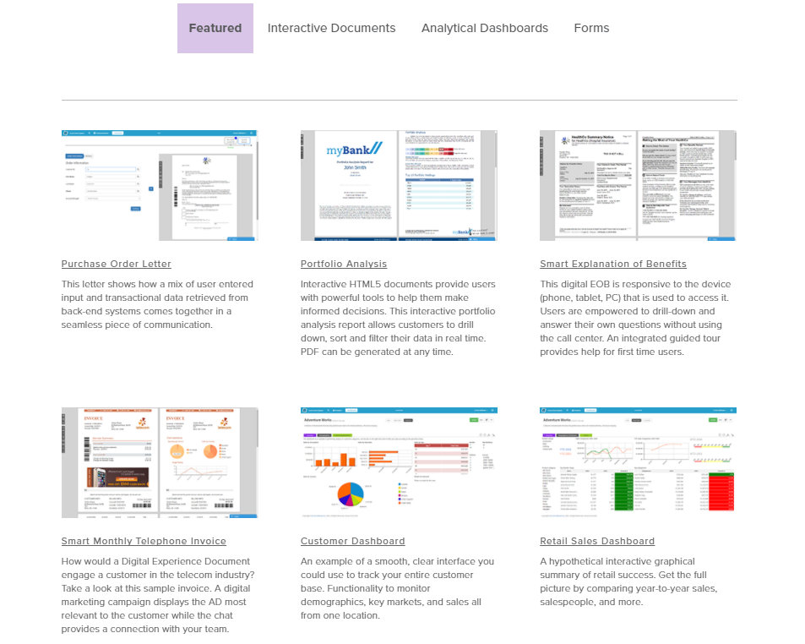

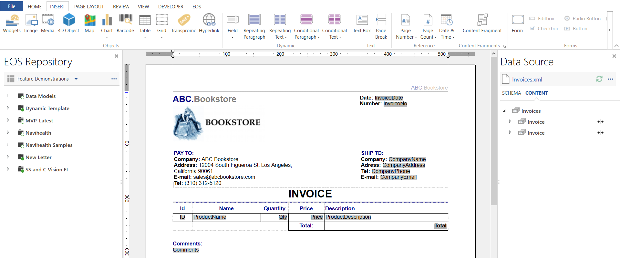

Conditional para – very common ask

Use existing conditional para. 1 or 2 clicks to change it.

EOS -

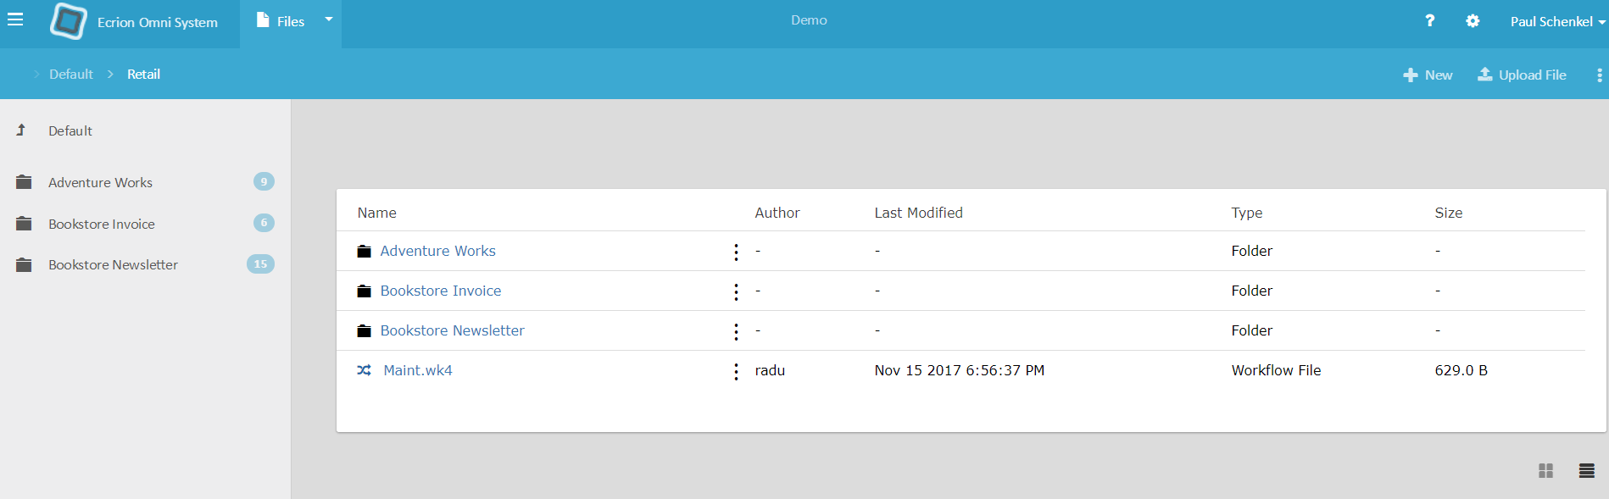

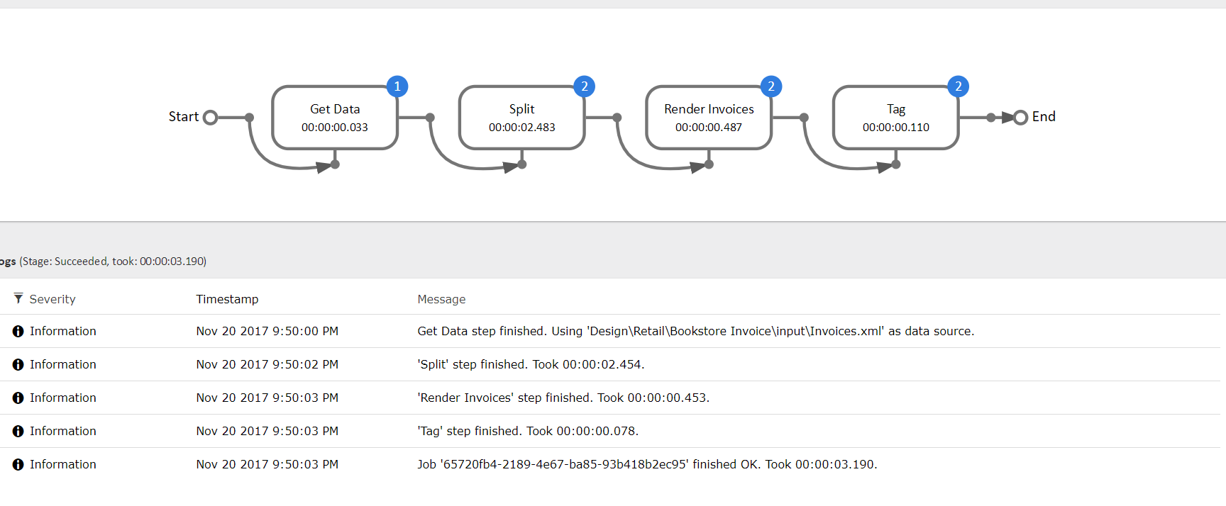
- Step 2, Select:
  - One from the customer’s industries (insurance, financial services, telco, etc.) to make the presentation more relevant, and thinking about what they and their competitors can do today, and would like to do in the future.
  - Interactive Documents (Insurance)
  - Smart Documents (Telecom)
  - Interactive Letter Generation (
  - Interactive Sales Dashboard (

- Smart Doc features to note:
  - Documents are served rather than delivered, which means we collect analytics.
  - Export to PDF for local print. Customers can still get hard copy
  - Tour feature – for complicated docs
  - Interactive BI Widgets
    - Demonstrate interactive display
    - Show data export menu: ability to deliver data to customer along with document. This is especially valuable for business-to-business documents.
  - Embedded forms (self-service)
  - Responsive: change up the width of the web page, talking about mobility of customers.

Composition: EOS Server Tour Stop – 20 mins

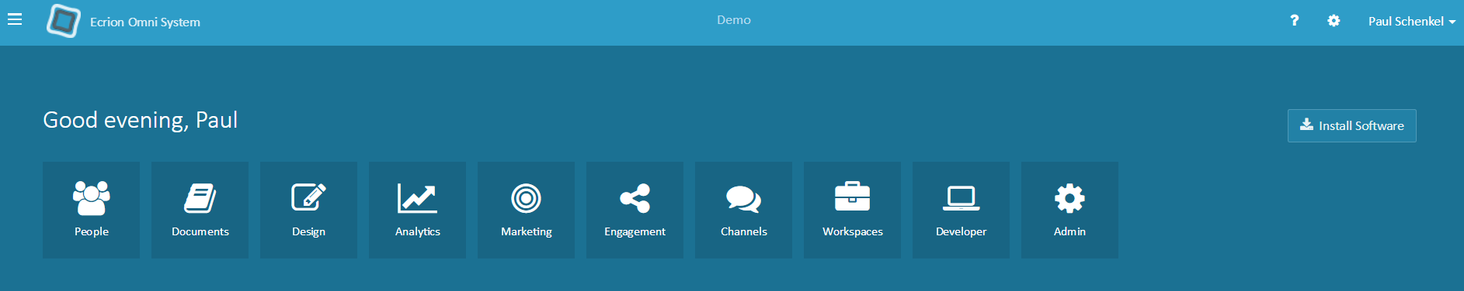

People – This places your customers identity in our CCM layer so that you can manage access, preferences and start to collect customer intelligence data about that individual.
Documents – This enables manual execution of our 3 types of use cases: batch, correspondence and on-demand.
Design - In the design module you are able to create new Communications as well as modify any communications you have access to in the environment. This module is available in EOS-CCM and EOS-CEM, if you do not see this module in your environment reach out to your account manager for upgrade options.
Analytics – This provides dashboards and reports that help you understand the trends and patterns in the data used to generate documents.
Marketing – Leverages business rules to apply specific ads to specific customer segments and collect results (clicks, open rates).
Engagement – Automated outbound communications triggered by individual customer behaviors and status.
Channels - Channels are used to deliver communications directly to the final recipients. These are available in EOS-CCM and EOS-CEM, if you do not see these options in your environment reach out to your account manager for upgrade options.

Workspaces - EOS Workspaces enable collaboration and storage of all assets involved in your customer communication management processes.
Workspaces are logical divisions of Environments, usually associated with departments within a company. They contain all the files needed for document production and provide restricted access to Enterprise Users, based on user rights.
Workspaces are available in EOS-DA EOS-CCM and EOS-CEM, if you do not see these options in your environment reach out to your account manager for upgrade options.
Developer – Provides access to API documentation, library downloads and sample code.
Admin – This allows the Administrator to port projects from one environment to another environment using credentials and other configuration that remain secure.

Transition is important, so they know we changed stops. Something like “That is a sample of a modern electronic document our system can produce. Now, we are going to move from the document to the production environment, where we will see how EOS orchestrates production of your documents”. The industry term for this is “composition”.
Don’t start at the main EOS screen. It breaks the narrative. We want to transition from seeing the document to the workflow that produced it. That keeps their train of thought going.
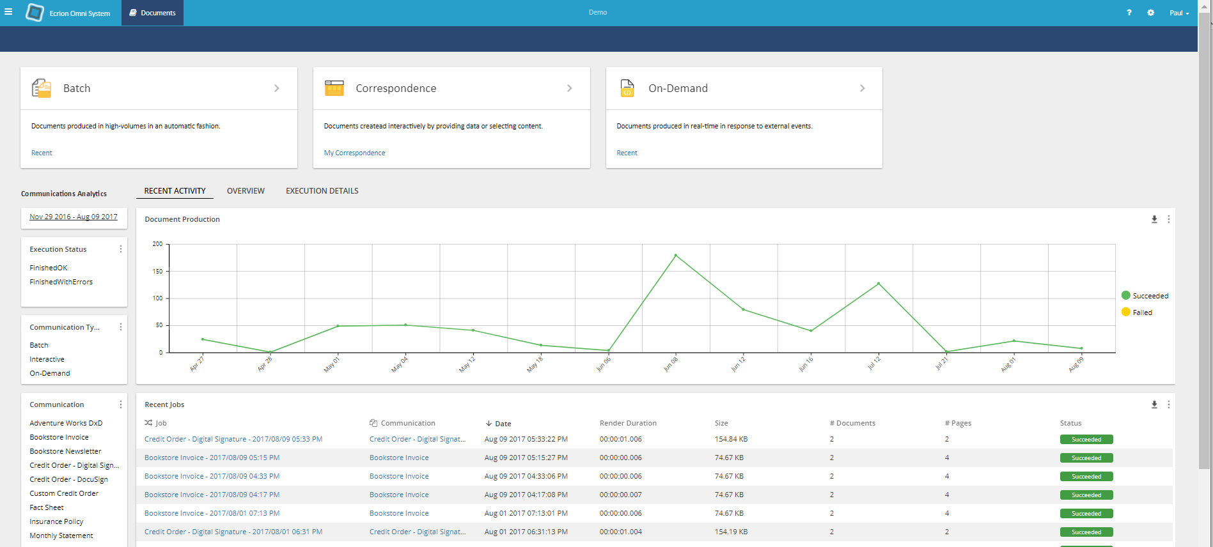

Job Tab
This tab should be an executed job, hopefully matching the sample from the previous tour stop.
- Mention “operations” view of completed job, this one is triggered by GUI, but many other ways to get a job started. (Flexibility, governance)
- Click on the green “100% Success” tab to show the workflow
- Talk through the workflow steps from left to right
  - Click on the “split” step to show the XML per doc
  - Click on the render step, and then click on one of the rendered documents

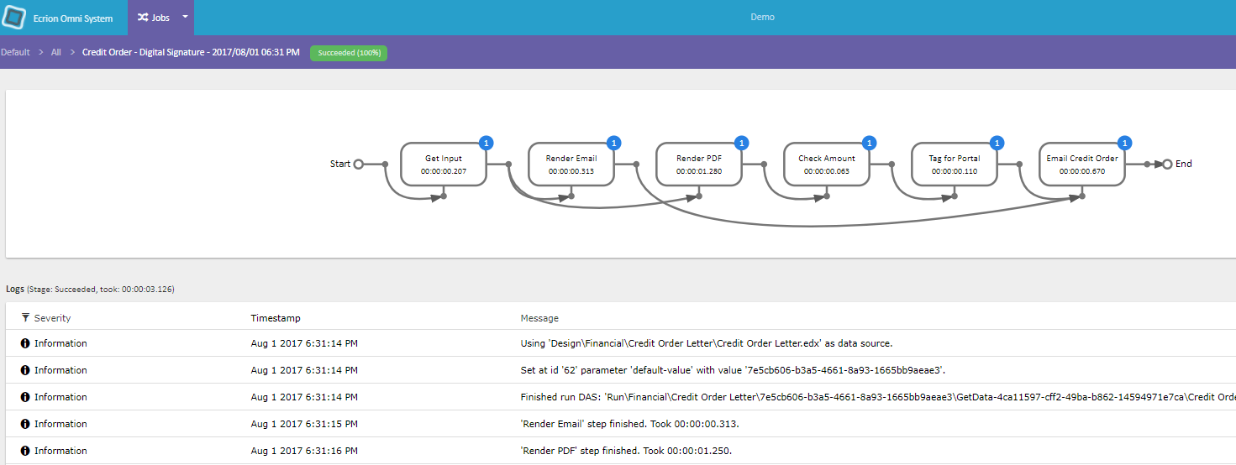

  - Mention the numbers and what they mean
  - Audit – history of job execution (governance)
- Use the triple dot option to view workflow, then open the editor on it
  - Talk about parameters for on-demand (Integration)
  - Pull down the actions and talk about some key actions
    - Render During this time, open the workflow’s render step, and talk through some of the parameters (e.g. output format).
    - Tag
    - Index
    - Merge
    - Custom (Integration!) This is access to the command line, where our workflow can send outbound data/events to their business logic

Main EOS Page

After working through the batch workflow, we want to step up the tour to the higher picture. Go to the main EOS screen, with Customers, Communications, Channels, and Workspace.
Our first step is to reconnect with the batch program we just ran. Talk about the high level, then start with communications.
- Customer Profiles used for targeting and personalizing outbound messages.
- Channels for managing outbound delivery
- Workspace is the repository of files and configurations that go into a project
- Communications control the execution of these workflows

Communications Page
We go into the communications page and explain what these three things are:
- On Demand
- Interactive
- Batch
Depending on the specific interest of the client, and time available, we can then go deeper

Batch
We already demonstrated a batch job, but we can use this interface to kick off the exact same one we walked through before.
- This is an interface for the operations manager
- The batch can be triggered manually, by schedule, or by data trigger
Open up the job after it completes. Don’t stick around, just make the narrative connection: we just ran the workflow we investigated.

Interactive, E-Mail Delivery, Digital Signature, and Review
If you think your prospect has any interest in forms, use Virtual Bank. Set it up in a tab ahead of time, and populate fields. It takes too long to populate them while they watch.
There are a few different workflows to pick from. One includes an integration with digiSign, one includes a review process. Make your decision on which to use by considering your prospect’s specific areas of interest.
You will have to adjust the demo ahead of time. The e-mail address for delivery is configured in the workflow, and is set to rick.ringel@ecrion.com by default. You will want to set this to an account that you can open.
- Overview:
  - Preview area
  - Form area – mention validation, and multiple steps
  - Timeline area – mention version history, and how status of document is tracked
  - Submit area – This is the place we invoke workflows, which have the same capabilities as we saw in the batch workflow.
- Step through form fields
  - Update a few of the inputs to and point out the real-time updates in the preview
  - Make sure you use the lookup feature, and talk to auto-fill
  - Submit it
- If you are running the “review” version, open up the task, start the task, then accept it. When that is done, the timeline on the document will show “accepted”. You can also show the comments on the left side. Again, this is only useful if the prospect has a specific interest in the review.
- Open up your e-mail client and open up the e-mail & attachment. I have a rule in my outlook account, so all messages from EOS go into a special folder. I have that folder open in Outlook before I start the demo, so the shared screen does not show my inbox to everybody.
- If there is any interest in signatures, show in the PDF display that the document is signed.

On Demand
We don’t want to get into this. Just mention its use case – integration with web servers and such, so a call into EOS invokes a synchronous workflow that produces a document and includes it in the response.

Channels
No need to demonstrate. Talking points:
- Print queues give oversight on print stream management
- E-mail queues give priority and oversight on outbound e-mails

Customers
We will click into this, and talk about customer accounts and customer portals.
Don’t spend any time here if your prospect is uninterested in CCM, but only looking to do document assembly. You may mention it in passing: “If your organization ever moves toward customer engagement projects, this set of features will help you target and personalize your outbound communications”.

Accounts
We want just to get to the place where the customer accounts are listed, and then while you talk, open one up.
- Customer profiles provide outbound document personalization and targeting
- They synchronize with external sources, such as CRM systems, through a data model. During production runs, customer data can be drawn from here more efficiently.
- Custom fields and tags here allow for segmentation of customers without pushing new fields back into enterprise data.

Portals
If your prospect has asked about features that could use our portal, then take them into this. Otherwise, skip over it. We don’t want to try to sell portal to prospects that don’t already have a notion of providing a document management interface to their customers.
- Talk about the use case
- Talk about setting up customer-specific credentials
- Move to a tab that has a user portal open. Show some docs, and talk about customization/branding.

WorkSpace

Just talking points. Don’t click in.
- Read/write Permissions per user or group
- Hold related projects
- Are the repository for files edited in EDS, the desktop tool

Use the discussion of the repository to transition to EDS.

Authoring: EDS Tour Stop – 10 mins

Again, the transition is important. We want to be sure the audience mentally checks out of EOS and starts thinking desktop. You can ask for questions about EOS, and draw it to a feeling of completion. Then, we move on to EDS.
Keep in mind your audience. The people in the room may not be the ones that use these tools, so keep the tour guide metaphor in mind. Terms like “Your content providers…” give them the right perspective.
Be sure you not only have your documents open, but 1) you are connected to EOS, and 2) the data source is configured and works, and 3) preview is tested and works in PDF and EDS.
- EDS Is three integrated tools for three different skill sets. Collaboration!
- First, Publisher
  - Overview of Tool
    - Feels like MS Office (short learning curve)
    - Right hand side – data model (Collaboration)
    - Left hand side – EOS repository for check in/out (Collaboration!)
    - Top Ribbon
  - Feature Drill-down
    - Drag & Drop data fields.
      - Don’t actually do it unless you practice where to drop the fields. In many of our samples, dropping is hard because the documents are made up of subdocuments, and you cannot drop onto them.
      - Fields can also be tables, made from a series of elements in the data source.
    - Mention Repeating paragraphs and text, building on the idea of repeating elements.
    - Conditionals
      - This is one of the key features, so slow down here and make sure it is clear.
      - The data source is not just for direct content, but it can be used to control whether entire sections of the document are included. The data is available for control, as well as content.
      - During this time, pull down from the ribbon, to the first level. There are some easily understood conditions here, like “If exists”, and “If Contains”. This is a good backdrop for the discussion.
      - If a prospect has specifically mentioned that conditional content is important to them, and you have time to practice…
        - Turn on the annotation view
        - Build a simple conditional to show how easy it is
        - Be sure you know ahead of time exactly where you will place the conditional, and what condition you will create.
    - Properties
      - Click on an area to bring up properties
      - Show how things like color & font can be set
      - Show how these can be based on content. The “Fx” feature makes these fields controllable through the data source.
    - Languages, if appropriate.
      - If the prospect has specifically asked about multi-lingual ahead of time, pick a demo that has a Spanish translation. The Spanish version should have been included in the EOS demo
        - Show the “manage translations” pane. You should see the Spanish translation show up.
        - If this is a big deal to the prospect, set the active language to Spanish. When we do a preview later, it will render in Spanish. Be sure to practice this ahead of time, and don’t do this unless your audience is obviously concerned about how this works.
        - Do not open up the translation editor unless there is a specific question. It is an unimpressive text file that is hard to navigate and edit.
        - Speak to the concept – each native phrase is seeded into the translation file, and that file is where a linguist provides the translation. On EOS, at run time, the language is passed into the render step, usually based on the content of the XML data.
      - If there is no prelim interest in multi-languages, just show the ribbon’s icon, and make a few statements about how a template can be rendered into different languages. No need to go into how.
    - EOS Repository
      - You will probably have to go to the EOS part of the ribbon and click “show”
      - This is all about collaboration
      - Pull down one of the file menus, and mention the basic check-in, check-out, lock sort of features.
      - This is all about collaboration. Other people using other tools make their components accessible to each other through this integration.
    - Insert
      - Step through the different things that can be inserted
        - Widgets from the BI architect
        - Images, can be clickable to drive traffic to your site
        - Transpromo: for personalized message delivery. Reserves a spot in the doc. If you demoed the market campaign in EOS, tie this to that.
        - Subdocuments (Collaboration!) This is how multiple content editors can contribute, and how we achieve reuse of document components. If you get questions/interest, you can open one from clicking on the right part of the sample template. Don’t create one on the fly!
        - Forms. Just talk about building internal forms. Don’t build anything.
    - Preview
      - Key point: this is a test environment. Docs can be rendered in different formats without going to EOS.
      - Show PDF preview
      - Show ESD preview
  - Document Views
    - If your audience is highly technical, and they ask about our design details, show them the XML view
      - XML-FO format for all the saved templates
      - Just spend a few seconds stepping through, without taking time to focus. We want to avoid conversation about details! But, let them know the template text is accessible to them.
- Data Modeler
  - Have the data model open
  - Collaboration!
    - IT people in charge of gather data for content writers and data visualization staff.
    - Changing enterprise data structures and architectures is absorbed in the model, protecting the investment in templates.
  - Three areas of design surface
    - Left side – inputs
    - Right side – abstract XML schema used in the template
    - Middle – data wrangling, using operations like joins and filters to construct the abstract model for a single invoice
  - Talk to the insert bar
    - SQL database & Queries
    - XML
    - CSV
    - Spreadsheet
    - System integration, like
      - salesforce
      - EOS Customers
      - Microsoft CRM
  - Executed on EOS during workflow. This is producing a script that generates the data, not the data itself.
  - Preview, if your audience is interested. Otherwise, no.
- BI Architect
  - Have a document already loaded
  - Just talk to the insert bar
  - Mention that this is intended for your staff that has data visualization skills. They can contribute visuals without getting involved in content or layout.
  - “Import” widgets to Publisher allows content writers to do layout with charts without understanding how data visualization works.

Governance: EDS and EOS together

Use judgement in this section. Some prospects care deeply about some of these features, some are uninterested (“leave it to IT”). Lead with conversation to find interest, and be ready to show using prepared browser tabs.
The key here is flexibility to enforce policies set up by our customers, and to bring stakeholders into the process without overwhelming them with technology.

- (EOS) Advanced Search
  - Make produced documents “findable” for use cases like customer service
  - Make templates and digital assets findable without a universally agreed storage structure
- (Publisher) Style management –
  - imported style sheets
  - subdocuments and content library
  - Shared digital assets of all kinds (e.g. images)
- (EOS) Environments
  - Supports security policies over different environments – e.g. protect PII from developers.
  - Projects are portable from one environment to another – credentials reside in environments.
- (Publisher) Repository connects authoring to composition
  - Version control, check-in, check out, project spaces
  - Separate repository for every environment
- (EOS) Review and Approve
  - Release Management. Gatekeeper between environments (Demo if deemed important).
    - Can include multiple reviewers – enforces policy set by organization
    - Audit trail generated (show completed R&A with comments, etc.)
  - In-Place approval (Demo if deemed important)
    - Different policy for low-risk updates (e.g. marketing message)
    - Composition selects approved version rather than latest version
- (EOS) Security
  - Identity management:
    - EOS
    - External
    - SSO
  - Access policies
    - Groups
    - Users

Tour Recap
- Flexibility to integrate to existing data and business process, and to deliver over traditional print and modern electronic channels.
- Agility to generate new and updated documents without IT staff, in hours instead of weeks
- Governance to involve stakeholders and delegate responsibilities for specific components to different groups, and to impose different policies for different components.

Integration

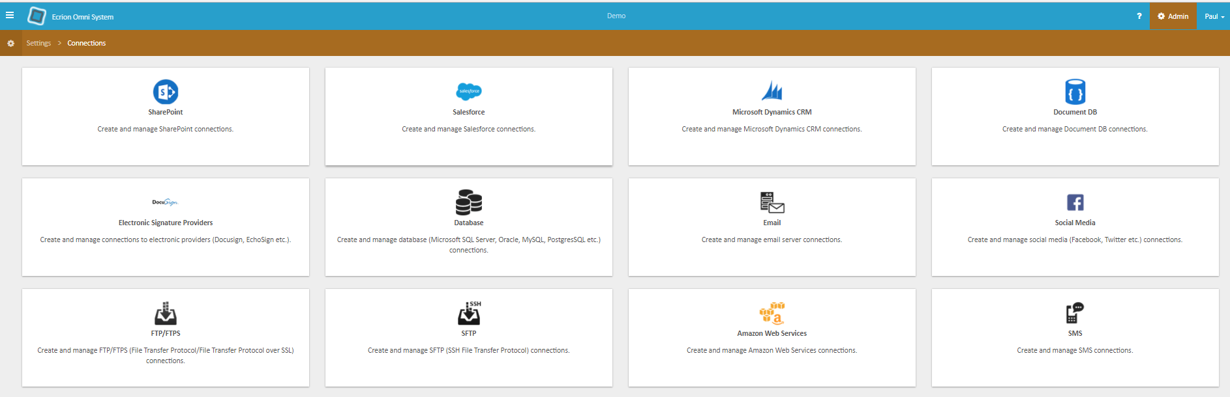

8 Bit Platoon

By: ___________________________
Name: ___________________________
Title: ___________________________
Date: _______________________

ECRION SOFTWARE INC

By: ___________________________
Name: ___________________________
Title: ___________________________
Date: _______________________

