http://www.commuforce.com/wp-content/uploads/2018/01/400dpiLogoCropped-114-e1515956204576.png

***CommuServe***

**Architecture Document**

**Version 0.1**

Table of Contents

Change History 4

1 Introduction 5

2 Logical Architecture – CommuServe Microservices 6

3 Technical Architecture 7

4 Technology Components/ Tools 8

4.1 CommuServe Application Platform 8

4.2 CommuServe Communication Platform 8

4.3 Development Environment 8

4.4 Deployment Environment 8

5 Services Interaction 10

5.1 Communication 10

6 Detailed Design 10

7 DevOps 10

7.1 Tools 10

7.2 Development Approach 10

7.3 Coding Standards 10

8 Non-Functional Requirements 10

9 Product Testing Approach 10

9.1 TDD 10

9.2 NFR Testing 10

10 Deployment Approach 10

11 Licensing Checklist 10

12 Risk 10

13 Open Items 10

14 Appendix 12

14.1 Template Cross Platform Compatibility/Open Standard Study 12

14.2 Technology Components/ Tools Decisions 13

14.2.1 ESB Layer 13

14.2.2 Reporting Components 13

14.2.3 Workflow/ Rules Engine 13

14.2.4 UI Framework 14

14.3 Deployment Environment 14

**Change History**

|  |  |  |  |  |
| --- | --- | --- | --- | --- |
| **SNo** | **Date** | **Updates** | **Version** | **Author** |
| **1** | **23-May-2018** | **Initial Version** | **1.0** |  |
|  |  |  |  |  |
|  |  |  |  |  |
|  |  |  |  |  |

**Introduction**

**CommuServe is a Customer Communication Management (CCM) solution developed by CommuForce Inc.**

**CommuServe is an AI based end to end solution, handling all aspects of CCM from incoming communication to outgoing messages, both for real time applications and large batch processing.**

**The following are the objectives of the CommuServe technical architecture:**

1. **Portability – support multiple 3rd party tools**
2. **Easy to change - Microservices based**
3. **Pluggable – ability to add connectors to multiple input and output channels**
4. **Scalable**
5. **Secure**

**Other deployment related capabilities:**

1. **On-premise or cloud-based deployment supported**
2. **Ability to enable/ disable specific services**

**Logical Architecture – CommuServe Microservices**

**The *CommuServe* product is built based on microservices architecture. All the capabilities of the product are designed as independent services, as depicted in the logical architecture diagram below.**

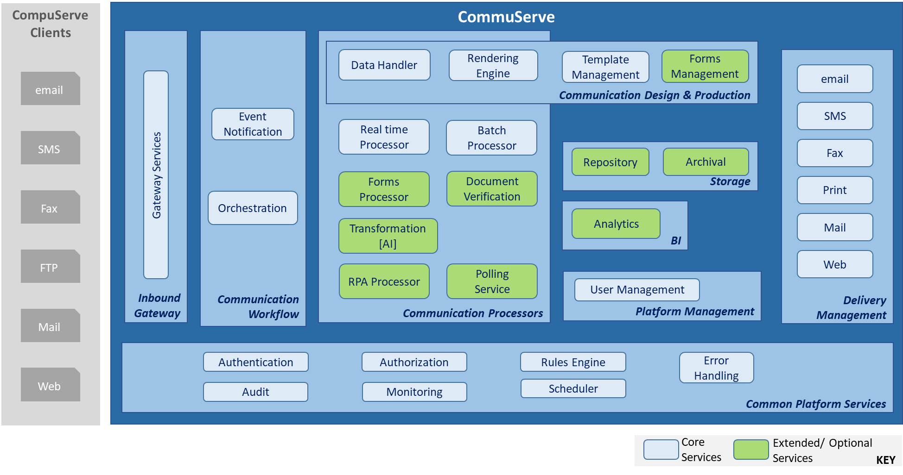

Figure 1 - CompuServe Microservices

**Technical Architecture**

**Technology Components/ Tools**

CommuServe Application Platform

|  |  |  |
| --- | --- | --- |
| **SNo** | **Software** |  |
| **1** | **Microservices Framework** | **Spring Boot** |
| **2** | **UI Framework** | **Backbone/ NodeJS/ AngularJS** |
| **3** | **Database** | **MySQL** |

CommuServe Communication (ESB) Platform

|  |  |  |  |  |
| --- | --- | --- | --- | --- |
| **SNo** | **Software** | **AWS** | **Azure** | **On Premise** |
| **1** | **JBoss Fuse** | **Supported** | **Supported\*** |  |
| **2** | **Mulesoft** | **Supported** | **Supported** |  |
| **3** | **WS02** | **Supported** | **Supported** |  |
| **4** | **Workflow/ Events Database** | **NoSQL** | **NoSQL** | **NoSQL** |

Development Environment

|  |  |  |  |  |
| --- | --- | --- | --- | --- |
| **SNo** | **Software** | **AWS** | **Azure** | **On Premise** |
| **1** | **Eclipse IDE** |  |  |  |
| **2** | **Source Code Repository** | **Github**  **Integrates with**  **AWS Code Commit** | **Github** | **github** |
| **3** | **Continuous Integration** | **Jenkins** |  |  |

Deployment Environment

|  |  |  |  |  |
| --- | --- | --- | --- | --- |
| **SNo** | **Software** | **AWS** | **Azure** | **On Premise** |
| **1** | **Container** | **Docker** | **Docker** | **Docker** |
| **1** | **Microservices management** | **Amazon EKS (Kubernetes)** |  |  |
| **2** | **Load Balancer & API Gateway** |  |  |  |
| **3** | **Security** |  |  |  |
| **4** | **Logs Management** |  |  |  |
| **5** | **Monitoring** |  |  |  |

**Services Interaction**

Communication

**Detailed Design**

**Refer to the individual service detailed design documents.**

**DevOps**

Tools

Development Approach

Coding Standards

**Non-Functional Requirements**

**Product Testing Approach**

TDD

NFR Testing

**Deployment Approach**

**Licensing Checklist**

**Risk**

**Open Items**

**Appendix**

Cloud Platform

|  |  |  |  |
| --- | --- | --- | --- |
|  |  | **AWS** | **Azure** |
| **1** | **Pros** | * **Integrated with wide range of 3rd party tools** | * **Better at Hybrid cloud solutions** * **Better compliance (according to their website)** * **Advantage if already on Microsoft platform, better integration with developer tools** |
| **2** |  |  |  |

**Template Cross Platform Compatibility/Open Standard Study**

|  |  |  |  |  |
| --- | --- | --- | --- | --- |
| **SNo** | **Software** | **Pros** | **Cons** | **Notes** |
| **1** | **Ecrion Design Studio, Data Modeller** |  |  |  |
| **2** | **JasperReports from Jaspersoft** | * **Popular open source report designer & rendering engine** | * **Report designer, not robust, and may not be appropriate for business users** |  |
| **3** | **BIRT from Eclipse Foundation** |  |  | **Project sponsored by ‘OpenText’** |
| **4** | **Apache FOP** | * **Java XSLT transformer can be leveraged** * **Ecrion is XSL-FO compliant** | * **Outdated, not as popular as CSS for web pages** | Based on w3c XSL-FO standard.  XSL-FO is part of XSL (Extensible Stylesheet Language), a set of W3C technologies designed for the transformation and formatting of XML data. |

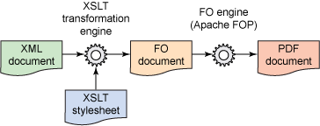 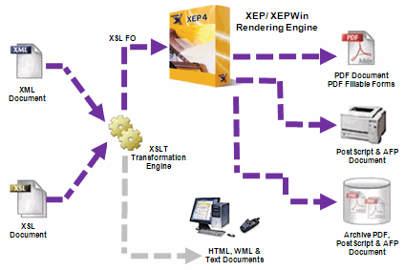

**Technology Components/ Tools Decisions**

ESB Layer

|  |  |  |  |  |  |  |
| --- | --- | --- | --- | --- | --- | --- |
| **SNo** | **Software** | **Pros** | **Cons** | **Notes** | **Selected** | **Date** |
| *****ESB***** | | | | | | |
| **1** | **MuleESB from MuleSoft** |  |  |  |  |  |
| **2** | **JBoss Jfuse** |  |  |  |  |  |
| **3** | **Spring with Apache ActiveMQ** |  |  |  |  |  |
| **4** | **WSO2** |  |  |  |  |  |

Reporting Components

Workflow/ Rules Engine

|  |  |  |  |  |  |  |
| --- | --- | --- | --- | --- | --- | --- |
| **SNo** | **Software** | **Pros** | **Cons** | **Notes** | **Selected** | **Date** |
| **1** | **JBPM** |  |  |  |  |  |
| **2** | **Drools** |  |  |  |  |  |

UI Framework

|  |  |  |  |  |  |  |
| --- | --- | --- | --- | --- | --- | --- |
| **SNo** | **Software** | **Pros** | **Cons** | **Notes** | **Selected** | **Date** |
| **1** | **Backbone** |  |  |  |  |  |
| **2** | **Node JS/ ext js** |  |  |  |  |  |

Deployment Environment

|  |  |  |  |  |  |  |
| --- | --- | --- | --- | --- | --- | --- |
| **SNo** | **Software** | **Pros** | **Cons** | **Notes** | **Selected** | **Date** |
| *****Container***** | | | | | | |
| **1** | **Docker** | * **Popular tool** | * **Community version does not support enterprise level OS such Red Hat Linux** * **Security features available only in licensed version** |  |  |  |

**Open Items**