http://www.commuforce.com/wp-content/uploads/2018/01/400dpiLogoCropped-114-e1515956204576.png

***CommuServe***

**Capabilities Document**

**Version 0.1**

Table of Contents

Change History 4

1 Introduction 5

1.1 CommuServe Capabilities Overview 5

1.2 CommuForce Solutions 6

1.3 Customer Information 7

1.4 Commuforce and ecrion 7

2 CommuServe Services 8

2.1 Core Services 8

2.2 Extended Services 8

3 Core Capabilities 9

*3.1* *Process incoming communication from multiple channels* 9

*3.2* *Design templates for communication* 10

*3.3* *Define dynamic data in communications* 11

*3.4* *Generate personalized communication* 11

*3.5* *Event handling* 12

*3.7* *Orchestration of workflow* 13

3.8 Workflow Components 17

*3.9* *Generate personalized on-demand communication* 18

*3.10* *Generate personalized communication at scheduled intervals* 18

*3.11* *Multiple output delivery channels* 18

*3.12* *User Management* 19

3.12.1 Login Screen 19

3.12.2 Home Screen 19

3.13 User Definition 19

3.14 User List Definition 19

3.15 User List-Event Id Definition 19

4 Extended Template management service 20

*4.1* *Template Management* 20

*4.2* *Form management service* 20

*4.3* *RPA Processor - Automated processing of incoming communication* 20

*4.4* *Transformation (migration) services* 20

*4.5* *Scheduled polling for incoming communication* 21

*4.6* *Storage services* 22

*4.7* *Business Intelligence* 22

*4.8* *Document Verification Services* 22

*4.9* *AI services Capabilities* 22

5 Error Handling 23

6 Audit Requirements 23

**Change History**

|  |  |  |  |  |
| --- | --- | --- | --- | --- |
| **SNo** | **Date** | **Updates** | **Version** | **Author** |
| **1** | **9-May-2018** | **Initial Version** | **1.0** |  |

**Introduction**

**CommuServe is a Customer Communication Management (CCM) solution developed by CommuForce Inc.**

**CommuServe is an AI based end to end solution, handling all aspects of CCM from incoming communication to outgoing messages, both for real time applications and large batch processing.**

CommuServe Capabilities Overview

**The following are the core high-level capabilities of the CommuServe solution:**

1. **Process incoming communication from multiple channels – email, SMS, Fax, FTP, mail and web clients**
2. **Design templates for communication - optimized for different UI screen sizes, desktop & mobile devices**
3. **Define dynamic data in communications - map data elements to external data sources - CSV, XML, Microsoft Excel, RDBMS, No SQL database**
4. **Generate personalized communication – Multiple output formats supported including XML, HTML and PDF, using the predefined templates and dynamic data**
5. **Event handling – Incoming messages/ service requests to be managed as ‘events’ that have associated workflow**
6. **Orchestration of workflow – define customizable sequence of communication processing, with automatic transmission to next processor**
7. **Generate personalized on-demand communication – for real time content in web applications**
8. **Generate personalized communication at scheduled intervals – for bulk communication at regular time periods**
9. **Multiple output delivery channels – email, FTP, SMS, mail and web clients**
10. **User Management service**

**The following are the specialized or extended (optional) capabilities of the solution:**

1. **Template management service – to manage templates across business departments and to aid in governance by the compliance team**
2. **Form management service – customer form generation, data capture and storage of information**
3. **RPA Processor - Automated processing of incoming communication - using natural language (NL) processing or AI to decipher the content e.g. incoming insurance form processing, and to map the message to an ‘event’.**
4. **Transformation (migration) services - to move customer templates from existing CCM solution to CommuServe**
5. **Scheduled polling for incoming communication - to check for updated incoming messages, such as file locations for news bulletins etc.**
6. **Storage services – repository and archival services of templates, forms, generated communication documents and other incoming files/ communication**
7. **Business Intelligence - analytics of customer communication**
8. **Document Verification services – Verification of two different versions of the same communication, useful for transformation (migration) output verification (Paloma Print Perfect)**
9. **AI services – applied for workflow machine learning (Workfusion), migration service, orchestration and automated processing of incoming communication (processing of bulletins for mandatory legal content in customer communication)**

CommuForce Solutions

|  |  |  |  |
| --- | --- | --- | --- |
|  | ****CommuFoundry**** | ****CommuXForm**** | ****CommuServe**** |
| *****CommuServe Core Services***** | | | |
| **Process incoming communication from multiple channels** | **Y** | **Y** | **Y** |
| **Design templates for communication** | **Y** | **Y** | **Y** |
| **Define dynamic data in communications** | **Y** | **Y** | **Y** |
| **Generate personalized communication** | **Y** | **Y** | **Y** |
| **Event handling** | **Y** | **Y** | **Y** |
| **Orchestration of workflow** | **Y** | **Y** | **Y** |
| **Generate personalized on-demand communication** | **Y** | **Y** | **Y** |
| **Generate personalized communication at scheduled intervals** | **Y** | **Y** | **Y** |
| **Multiple output delivery channels** | **Y** | **Y** | **Y** |
| *****CommuServe Extended (Optional) Services***** | | | |
| **Template management service** | **Y** | **Y** | **Y** |
| **Form management service** | **Y** | **Y** | **Y** |
| **RPA Processor - Automated processing of incoming communication** |  |  | **Y** |
| **Transformation (migration) services** |  | **Y** | **Y** |
| **Scheduled polling for incoming communication** |  |  | **Y** |
| **Storage services** |  |  | **Y** |
| **Business Intelligence** |  |  | **Y** |
| **Document Verification Services** |  | **Y** |  |
| **AI services** |  |  | **Y** |

Customer Information

Commuserve will not store Customer information in the product. All required data will be obtained, as required, from the external Customer Management System, for further processing of communication.

The repository and archival service can leverage existing customer data storage solutions, and hence inherently have security & privacy enforcements in place.

Commuforce and ecrion

|  |
| --- |
| **The first version of Commuserve will be built on the ecrion product. The Commuserve product will include support for other popular communication tools in future.**  **The following are key services Commuserve provides utilizing features of ecrion:**   * End to end communication processing – from inbound processing, communication processing automation to outbound communication generation * Template management – taxonomy management, to clearly catalogue relationships between templates, and to support standards by usage of common re-usable content * Governance/ Compliance - Ability to monitor and automate processing of incoming compliance communications, that needs template content to be updated |

**CommuServe Services**

**The CommuServe product has a set of core intrinsic services as well as the extended/ optional services.**

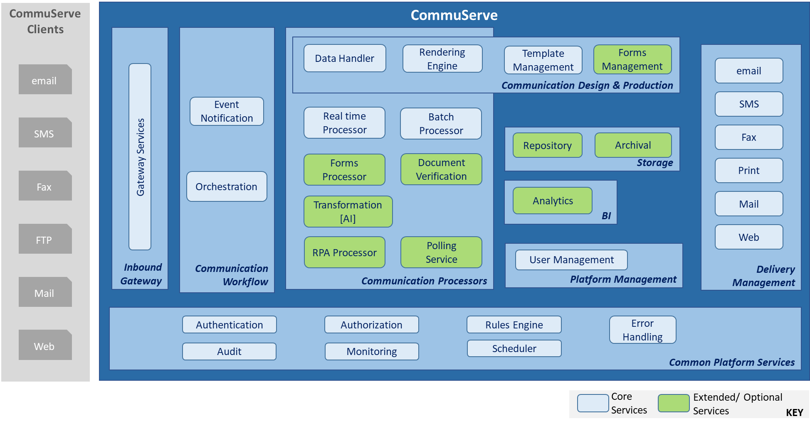

**Figure 1 - Core and Extended Services of Commuserve**

Core Services

**The core services of Commuserve, which will be available for all versions of the product are:**

* **Inbound Gateway**
* **Communication Workflow**
* **Communication Design & Production**
* **Real time processing**
* **Batch Processor**
* **Delivery Management**
* **User Management**

Extended Services

**The optional/ extended services of Commuserve, available for only specific versions of the product are:**

* **Forms Management**
* **Transformation**
* **Polling Service**
* **Analytics**
* **Storage**
* **RPA Processor - Image Recognition & Machine learning (RPA and AI)**

**Core Capabilities**

Process incoming communication from multiple channels

Design templates for communication

**Template Definition**

|  |  |  |  |  |  |  |  |
| --- | --- | --- | --- | --- | --- | --- | --- |
| ****No**** | ****Template Name**** | ****Template Type****  ****Main/ Fragment**** | ****Department**** | ****Contains Template Fragments**** | ****Related Events**** | ****Owner User ID**** | ****Notes**** |
| **F099** | **Common Legal Clauses** | **Fragment** | **Compliance** | **None** |  |  |  |
| **F100** | **Copyright** | **Fragment** | **Compliance** | **None** |  |  |  |
| **FC01** | **Policy Legal Clauses for California** | **Fragment** | **Compliance** | **None** | **COM001** |  |  |
|  |  |  |  |  |  |  |  |
|  |  |  |  |  |  |  |  |
| **B001** | **Annual Premium Payment Reminder** | **Main** | **Billing** | **F099, F100** |  |  |  |
| **C098** | **Auto Insurance Policy document for California State** | **Main** | **Policy** | **F099, F100, FC01** |  |  |  |
| **C103** | **Life Insurance Policy document for California State** | **Main** | **Policy** | **F099, F100, FC01** |  |  |  |

**Automatic update of Templates/ Automatic Verification of template updates**

**The system can prompt the user with a list of templates (*and a hyperlink with url of template in ecrion/Compuserve repository*) associated with the event, say policy update for California.**

***The user then needs to manually update the template. <*Automatic update may be possible if complete file is being replaced>**

Define dynamic data in communications

Generate personalized communication

Event handling

|  |  |  |  |
| --- | --- | --- | --- |
| ****SNo**** | ****Description**** | **Tech** | ****Use case/ Product Mapping**** |
| **1.1** | **Incoming messages (communication) are processed from all input channels.** |  |  |
| **1.2** | **A message scanner ‘reads’ the message and determines the ‘event’ that has occurred.** | **Scanner - Rules Engine Processor/ NLP/ AI** |  |
| **1.2.1** | **If the message can be mapped to an ‘event’, then an ‘event’ is created and the message is placed in the appropriate ‘event’ queue.** |  |  |
| **1.2.2** | **If the message cannot be mapped into any event, it is placed in a queue for error/ manual processing.**  **This message would then be assigned to a business user’s inbox for further processing.** |  |  |
| **1.3** | **The event is taken up for further processing by respective event processor.** |  |  |
| **1.4** | **The processor for the event will use the event definition to determine next steps for the event.** |  |  |
| **1.4.1** | **If a new workflow needs to be created, it is created, and the first step is initiated.** |  |  |
| **1.4.2** | **If the event is a step in an existing workflow, then appropriate processing occurs as part of the selected workflow.** |  |  |

Orchestration of workflow

**Event Definition**

|  |  |  |  |  |  |  |
| --- | --- | --- | --- | --- | --- | --- |
| ****No**** | ****Event Name**** | ****Dept**** | ****Associated Workflow**** | ****Workflow Step****  ****0 – Create New**** | ****Owner User ID**** | ****Notes**** |
| **COM001** | **Legal Clause Update Bulletin for California State** | **Legal** | **Update Templates**  **(COM_W01)** | **0** |  |  |
| **PAR003** | **Customer address change – additional documentation provided** | **Customer** | **Customer Address Change Handling**  **(CUS_W03)** | **3** |  |  |

**Workflow Definition – Sample Update Templates**

|  |  |  |  |  |  |  |  |  |
| --- | --- | --- | --- | --- | --- | --- | --- | --- |
| ****No**** | ****Workflow Name**** | ****Dept**** | ****Workflow Sequence Number**** | ****Triggering Event ID**** | ****Step Processor**** | ****Assigned User ID**** | ****Approver User ID**** | ****Status**** |
| **COM_W01** | **Update Templates** | **Legal** | **1** | **COM001**  **(Legal Clause Update Bulletin)**  ***This could also be more specific, update policy clause for state ‘California’*** | **Determine the list of templates that will be affected by this change, and respective template owners**  **Intimate legal team user of event, and show him the list of other users (template owners) intimated of the change.**  **Legal team user can decide to add another workflow item (intimate additional user) to the current workflow.** |  |  |  |
|  |  |  | **2** | **User marks bulletin update as ‘handled’** | **Legal team user views and approves or rejects the workflow item.** |  |  |  |
|  |  |  | **3** | **All users mark bulletin update as ‘handled’** | **Workflow triggers message to ‘Approver’ to approve.** |  |  |  |
|  |  |  | **4** | **Approver approves bulletin handled** | **<Close this workflow.>** |  |  |  |

**Workflow Definition – Sample Address Change Request Handling**

|  |  |  |  |  |  |  |  |  |
| --- | --- | --- | --- | --- | --- | --- | --- | --- |
| ****No**** | ****Workflow Name**** | ****Dept**** | ****Workflow Sequence Number**** | ****Triggering Event ID**** | ****Step Processor**** | ****Assigned User ID**** | ****Approver User ID**** | ****Status**** |
| **FIN_W03** | **Form Handling** | **Finance** | **1** | **Customer uses the website to request for a form to fill in address change**  **Core system sends the request to Commuserve to generate a form for address change (different form, say for, different states)** | **Event created and processor creates a new workflow in Commuserve**  **Step one - use the core system provided customer data to create the form, with the help of associated template.**  **Form (pdf) is sent back to the core system** |  |  |  |
|  |  |  | **2** | **(PAR003)**  **Customer downloads the form, prints it & signs the document.**  **Scanned signed form is uploaded to the core system website.** | **Commuserve stores the scanned image in its repository.**  **It marks the form as complete in Commuserve (?)**  **Need tracking of form status - Yes**  **Intimates core system** | **99419**  **12355** |  |  |
|  |  |  | **3** | **Approver in core system approves the address change, core system intimates Commuserve** | **Commuserve marks the form processing as complete, indexes the scanned form as processing complete.**  **<Close this workflow>** |  |  |  |

Workflow Components

1. Start the workflow
2. Send and assign <workflow item> to user list/Approver queue <user id>
3. Generate a communication with this <data> and <template>
4. Send <generated communication> to output channel
5. Place a <workflow item> on this <ESB queue>
6. Send a service request to another system

Close the workflow

Generate personalized on-demand communication

Generate personalized communication at scheduled intervals

Multiple output delivery channels

User Management

Login Screen

|  |  |  |  |  |  |  |  |
| --- | --- | --- | --- | --- | --- | --- | --- |
| ****SNo**** | ****Screen Field**** | ****Description**** | ****Values**** | ****Required**** | ****Data Stored in CommuServe**** | ****Data Stored in ecrion**** | ****Notes**** |
| **1** | **UserId** | **User id to login to the CommuServe application** | **Characters & Numerals** | **Y** | **Y\*** | **N** | **LDAP product to be used** |
| **2** | **Password** |  |  | **Y** | **Y\*** | **N** | **LDAP product to be used** |

Screen Flow

1. Type in the user Id and password values, then click on ‘Log In’ button.
2. The CommuServe application verifies the credentials against the LDAP credentials.
3. If credentials are correct, the user views the Home screen.

Home Screen

The Home screen will have the following categories and links within each category:

1. Generate Reports
2. Generate real time report for view
3. Define schedule for batch reports
4. Initiate batch process for reports

User Definition

1. User id
2. Password
3. Department

User List Definition

1. User List ID
2. User List name
3. User Id <multiple>

User List-Event Id Definition

**Extended Template management service**

Template Management

Form management service

RPA Processor - Automated processing of incoming communication

Transformation (migration) services

Scheduled polling for incoming communication

1. The CommuServe application will, at regular intervals, check for updated bulletin files in a specified FTP location.
2. If any new files are found, processing of the files is initiated.
3. Based on the type of bulletin, the following processing occurs:

Storage services

Business Intelligence

Document Verification Services

AI services Capabilities

**Error Handling**

**Audit Requirements**